Reed 2nd Grade Child Development Parent Talk Notes
October 8, 2015
With psychologist Dr. Maya Van Putten, principal Dr. Mary Niesyn,
and teacher, Mr. Ross Modlin

Introductions.

Purpose of the meeting
- Partnership with parents
- For parents to get to know each other
- Answer any developmental questions parents have. Parents posed questions to start related to:
  - Homework
  - Recess
  - Chores
  - What makes for a good friend?
  - How to manage difficult friendships?
  - Competitive sports
There are 5 Major Areas of Child Development that will be covered in this talk. These include Physical, Cognitive, Social, Emotional and Moral development. The talk will try to paint a developmental picture of most second graders (who are 7 and turning 8) in each of these 5 areas.

- Physical Development
  - Time of gradual physical change
  - More coordinated physically
  - Sports – Emphasize fun, friendship and exercise over winning and losing. Most children cannot truly play traditional, unmodified team sports until about age 8.
  - Chores – They are physically capable of household responsibilities, and having them at home can lead to benefits in the classroom. Sample chores include:
      - Fold laundry
      - Garbage
      - Set table
      - Make bed
    - Completing chores teaches cause and effect. If you don’t do the laundry, then you won’t have socks!
    - I recommend that they don’t get paid for their chores. Being in a family means that you help out. Kids want a job, but don’t need/want a reward. Builds independence. Emphasize effort over perfection in the actual completion of the chore.
  - Physically, they are now capable of sitting and focusing for up to 20 or more minutes.
    - They may need a brain break: stretching, dancing, water breaks. We provide these in school.

- Cognitive Development
  - At age 7, they are approaching the end of this dramatic period of rapid cognitive growth that occurs between the ages of 5 and 7.
    - Most children are less egocentric now, are more rational, and are more aware of how they are perceived.
    - More aware of how others perceive or evaluate them
    - Most second graders state opinions clearly and are better at decision making
    - Parents often note a loss of innocence at this age. There is an increased self-consciousness. Children are often more sensitive at this age and possibly sadder (see emotional section).
    - Some degree of regression is common (typically in Spring): Kids may want to read Dr. Seuss books again for comfort as a subconscious reaction to understanding and perceiving more grown-up issues and events around them.
  - Kids have increased ability to understand complex issues (metacognitive ability)
    - Capable of richer conversations, complex games
    - Classroom: Reasoning ability increases. They are capable of more complex math.
    - World view: They begin to see a larger world, and to make connections between text and real life experiences.
    - They are entering the abstract world and leaving the concrete world.
      - Change dialogue from: we’re leaving now, to: we’re leaving in 30 minutes.
      - Ensure that protagonist in reading is similar age so kids don’t grapple with issues that are too mature. Beware, for example, of rushing into Harry Potter.
  - Homework was discussed in response to parent questions.
    - A portion of the spelling homework has been removed to reduce the packet and because it wasn’t useful.
    - Math homework has been temporarily added.
    - How do you know how much homework to provide your child?
      - Reading can be added after homework is complete.
      - Set aside 20 minutes for “homework time” on a timer. Lesson: Homework is a thing we do, we don’t have to like it. If the child cries for 20 minutes, then put the homework away and have the teacher address it in the classroom. The child will then need to go into school and to report that they did not complete their homework and to experience the natural consequence of the teacher’s disappointment. It could take 3 weeks to develop a habit of homework, but children will learn. We do not want homework to lead to lengthy home battles. If it does, discuss it with your teacher.
      - Dr. Niesyn shared that homework increases in 3rd grade, so it’s good to build the habit of homework responsibility now.
      - For homework perfectionists: Reserve a night for just focusing on the appearance of homework. Create a safe space to enjoy the product so other time can be set aside for the process.
      - A parent brought us the question of how to manage distractions and younger siblings during homework time? Build an “office” with screens or have a desk for a workspace. Use a timer for the younger child as well to look at books quietly while his sibling completes homework.

- Social Development
  - Many 2nd graders have close/best friends at this age and others play flexibly with multiple kids. If your child does not have a best friend, it’s OK! There are benefits that come from playing with a variety of children.
  - Parents are discouraged from using language about “best friends”
  - In general, children have more mature relationships now, and have less transient friendships at this age.
  - Some children at this age prefer to play with one friend. Playing alone at times is also still common and okay.
  - Boys and girls still play together; this will change at around age 8.
  - Children at this age can change friendships quickly. They can say that they have no friends. Tears over relationship difficulties are common.
    - Parent: Practice being a good listener and reflect their emotions. Try not to problem solve all the time. Sometimes listening is enough.
  - For girls, this can be an intense time socially. The big issue is dealing with learning how to be friends with and to play with multiple friends at once. This issue arises especially in the spring and is something that many girls will grapple with until about 4rth grade.
    - Instead of asking who your child plays with, ask what activity they played.
    - Discourage play with 2 kids, as 3 kids often do not play successfully together as a triad. Encourage your child to approach a single child or a group of three or more.
  - When should you report a social problem to a teacher?
    - If you hear the same concern 3 or more times, then escalate to the teacher. Otherwise, parents should practice being a good listener. Give kids the chance to work out small, everyday problems themselves. This builds resilience, independence, confidence with problem solving and readiness for larger issues in the coming years.
      - Getting information from your kids: Ask what was your rose today? What was your thorn?
      - Do not interview for pain! For example, if you know Jane was problematic the day before, don’t follow up the next day with a specific question about whether Jane was mean again today. This is not easy to do.
      - We do a lot in school to help children solve social problems, and we use the Kimochis program school wide to help them to develop social and emotional skills. Mr. Modlin discussed some strategies he uses with his students and showed the following choice wheel to illustrate ways that he helps students to learn to solve problems.
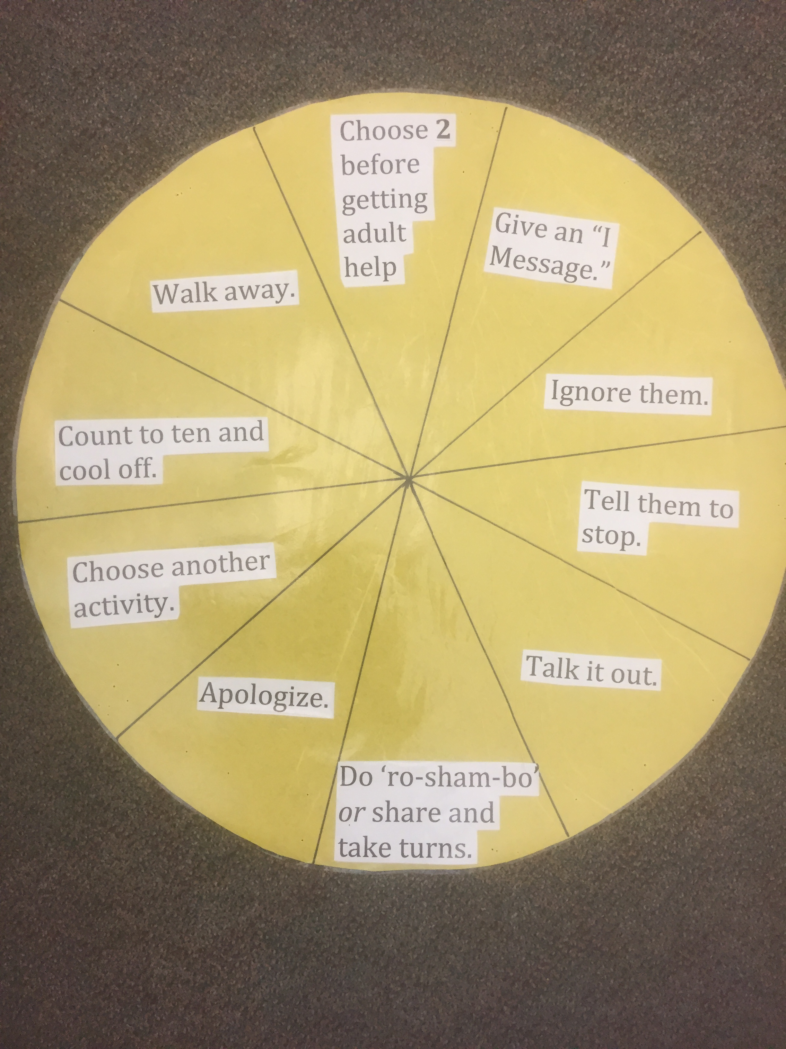
  - Bullying is a popular term these days.
    - Definition: Bullying is a pattern of unkindness from one child to another child that is repeated over time. One or two instances of meanness is not bullying.

- Emotional Development
  - 7 year olds now have increased emotional control, and we typically see this in school. They can better manage losing, frustration, disappointment, and they can collect themselves better afterwards. This increased emotional control will continue until adolescence.
  - Still, 7 is an emotional, somewhat self-conscious age.
  - 7 year olds can be moody, sulky, and can appear more worried and sad. 7 year olds can have stomachaches from worrying- this is not uncommon.
  - Kids at this age are bothered by mistakes and can try hard to make their work perfect. At age 8, most will bounce back a bit better from disappointment.
  - Anxiety is emerging as an issue of real concern in this district and in our broader culture as well. 1/3 of kids are depressed or anxious in HS, and 10% are on medication. College mental health centers are overrun with students who cannot manage the typical difficulties of college life. The good news is that we believe we know how to reverse this trend through careful parenting. As parents, we must allow our children to experience difficult emotions in small, developmentally appropriate increments. They should be allowed to wrestle with:
      - Frustration
      - Boredom
      - Anxiety
      - Sadness
        - Experiencing challenging emotions develops coping skills and resilience! If you protect them too much from experiencing these feelings, you are actually hurting them and impairing their later mental health and development into a healthy adult. Similar to muscles, they need to build up their disappointment muscle over time!
    - Another reason behind high anxiety rates is high pressure for achievement. Remember, earlier and more is not better! Instead, encourage kids to do their best in school and friendships, but beware of over emphasizing achievement. Don’t start building their resume now. They are 7 and don’t need that.

  - Various Parent questions/ Comments discussed:
    - School Lockdown: School drill scheduled for November. Discussed lockdown drills in general.
    - Does your child really know your home address and telephone number? Test if they can recite it to someone other than you. Create an opportunity for them to share what they’re learned in the world. Learning transfers when it’s internalized.

Thank you for joining us!

